**Design & Technology**

**Design influences, methods and figures**

**Materials required for questions**

* Pencil
* Rubber
* Calculator

**Instructions**

* Use black ink or ball-point pen
* Try answer all questions
* Use the space provided to answer questions
* Calculators can be used if necessary
* For the multiple choice questions, circle your answer

**Advice**

* Marks for each question are in brackets
* Read each question fully
* Try to answer every question
* Don’t spend too much time on one question

**Good luck!**

**Q1.** Which of the following designers, designed the ‘Juicy Salif’ – citrus squeezer

**A** Marcel Breuer

**B** Phillipe Starck

**C** Charles Eames

**Q2.** Which one of the following manufacturers, initially concentrated on designing and manufacturing ‘metal’ kitchenware?

**A** Alessi

**B** Raleigh

**C** Apple

**Q3.** Which one of the following designers, designed the London underground map?

**A** Philippe Starck

**B** Marcel Breuer

**C** Harry Beck

**Q4.** What design movement was Charles Rennie Mackintosh responsible for?

**A** Art deco

**B** Memphis

**C** Art Nouveau

**Q5.** What design movement was Ettore Scotsass responsible for?

**A** Memphis

**B** Arts and Crafts

**C** Bauhaus

**Q6.** The image below shows some Bauhaus style furniture

Give 2 key styles that represents the Bauhaus design movement. An example is given below **(2 marks)**

1. Economic use of material

2.

3.

**Q7.** One of William Morris’s views was that craftsmanship was an important part of the design and manufacture of products. Discuss how designers of the period were influenced by the principles of the Arts and Crafts movement **(8 marks)**

**Q8.** Discuss how the philosophy and design style of Art Deco have influenced the development of products **(8 marks)**

**Q9.** Discuss how the design of the building was influenced by Art Nouveau philosophies **(9 marks)**

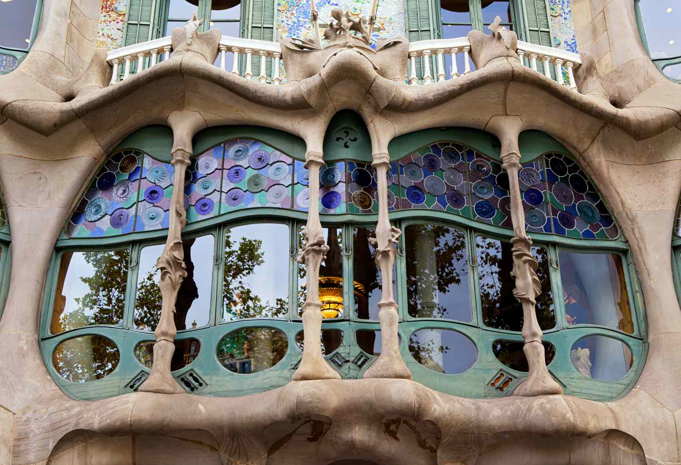

**Q10.** Discuss how the design of the building was influenced by Art deco philosophies **(9 marks)**

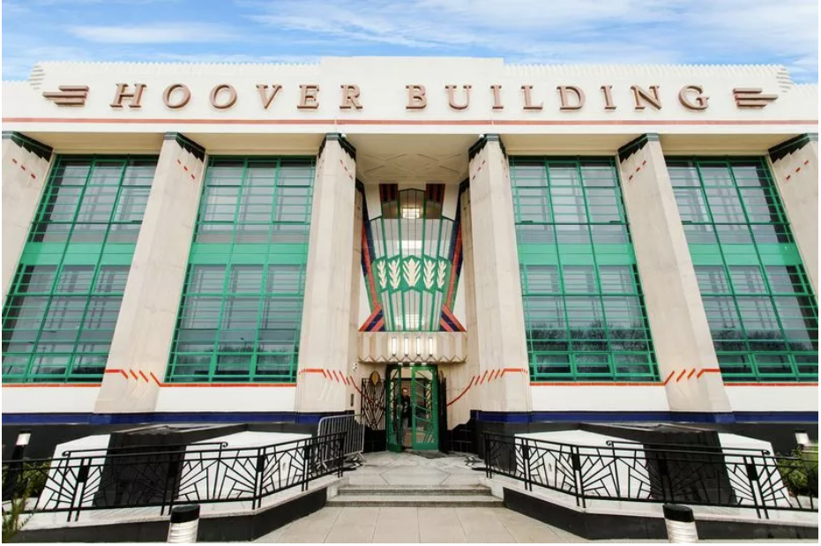

**Q11.** Using the image below as a reference discuss how the Memphis Design Movement has influenced consumer choice and expectations **(9 marks)**

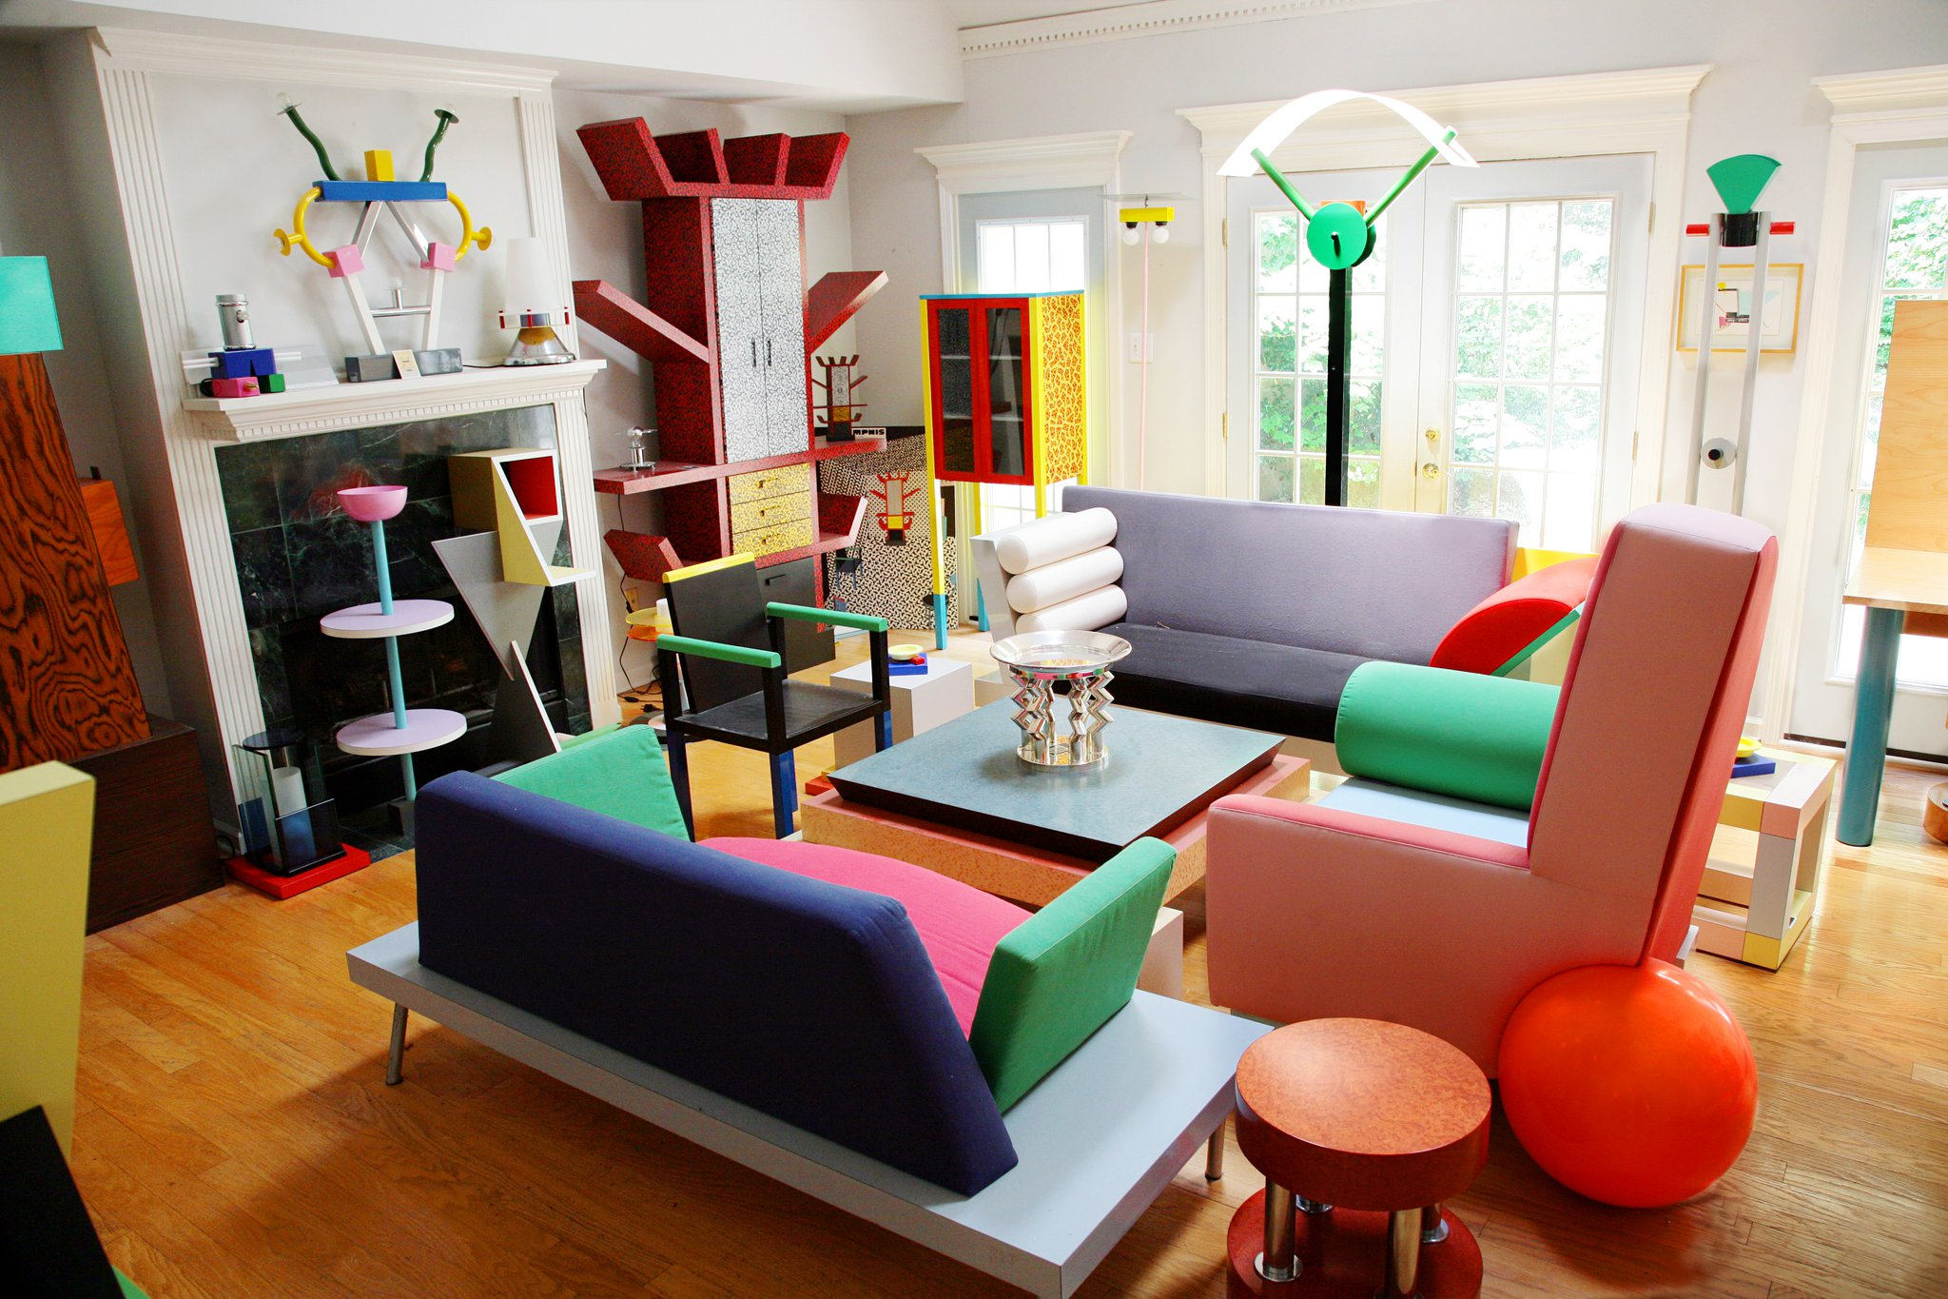

**Answers**

**Q1. B  
Q2. A  
Q3. C  
Q4. C**

**Q5. A**

**Q6.**

* Machine aesthetic using modern materials
* Geometric forms and clean lines
* Form follows function
* Products for the machine ages
* Everyday objects for everyday people

**Q7.**

* Form follows function
* Simplicity – removal of clutter
* Aimed to be affordable – Within reach of the masses, but rarely achieved
* Proportion – suitable size for current living conditions / not oversized
* Minimal decoration – humble / simple construction / rustic
* Experimentation with materials / techniques
* Preference for natural materials / beauty of natural materials
* Use unusual materials and precious metals
* Natural forms – plants / birds / animals
* Stylisation / symbolism / patterning / Medieval styles / stylised flowers / Celtic motifs / hearts / sailing ships
* Colour – used to provide unity and focus / highly decorated / coloured small areas
* Link between colour and nature
* Empowered people to design / make their own products / handmade
* Splendour and simplicity
* Were against industrially produced bland designs
* High quality / long lasting / handed down.

**Q8.**

* Eclectic / ideas come from a wide range of sources.
* Decorative / elegant / glamorous style.
* Geometric shapes / zig-zag lines / symmetry
* Bright / garish colours
* New materials (e.g. stainless steel, aluminium, plywood, bakelite)
* Opulent architectural and decorative arts style.
* Popular modernism.
* A response to human need for pleasure / a reaction against austerity.
* Primary purpose to be beautiful / ornamental.
* Both hand-crafted and machine-made items accepted.
* Affordable materials should be used.

**Q9.**

* Unity and harmony across the various fine arts and crafts
* Establishment of ‘modern’ urban life
* Designers appreciated the benefits of mass production
* Embraced technological advances of the time
* Embraced the aesthetic possibilities of new materials including glass and stained glass
* High standards of craftsmanship and design to everyday objects
* The form of an object should be expressed through its function and function should be expressed through decorative forms
* Influenced by natural forms
* Elongated curvy ‘whiplash’ lines
* Stylised flowers/leaves/roots/buds/seedpods
* Exotic insects and peacock feathers
* Use of the female form/languid female figures/long flowing hair
* Influenced by the arts and artefacts of Japan
* Vertical lines and height
* Celtic/Arabian/Ancient Greek patterns provided inspiration for intertwined ribbon patterns

**Q10.**

* Art Deco emerged from France in the 1920s
* Eclectic yet elegant style that drew on tradition yet simultaneously celebrated the mechanised modern world
* Opulent style a reaction to the forced austerity of the First World War
* Often referred to as ‘Hollywood’ style
* Ocean liner aesthetics
* Use of geometric forms and patterns
* Vertical lines, symmetry and repetition
* Expensive materials eg polished stone
* Use of bright and pastel colours for features, window and door frames
* Use of white / cream / pale colours for the ‘exterior envelope’ of the building
* Use of geometric fan motifs / sunburst motifs
* Simplified sculptural forms of African, Egyptian and Aztec art and architecture
* Influences from Tutankhamun’s tomb
* Explicit use of man-made materials
* Architecture that celebrated man’s technological achievements in building skyscrapers and ocean liners

**Q11.**

* Founder member Ettore Sottsass
* Originated in the Post-Modernist period
* Also known as the ‘New International Style’
* Influential products in the 1980s
* Challenged conventional shapes, colours, textures and patterns
* Inspiration from Art Deco and Pop Art
* Concepts in stark contrast to so called ‘good design’
* Products vibrant, eccentric and ornamental
* Influences of Indian and Aztec art
* Culture of rock music, travel and excess
* Gave consumers alternative and exciting choices
* Consumers needed to make brave bold purchase decisions
* Made consumers think about design
* May not attract consumers with traditional or conservative tastes
* Influenced designers such as Philippe Starck who maintained some of the philosophies.